Payer Electronic Data Interchange (EDI) Transaction Application Suite (TAS)

Fee Payment Processing System (FPPS)

Minimal Viable Product (MVP)

User Guide



July 2020

Department of Veterans Affairs

Office of Information and Technology (OI&T)

Revision History

NOTE: The revision history cycle begins once changes or enhancements are requested after the document has been baselined.

| Date | Revision | Description | Author |
| --- | --- | --- | --- |
| 7/31/2020 | 1.6 | Updated document for finalized MVP scope | Amelia Marple |
| 4/13/2020 | 1.4 | Updated document for MVP scope | Steven Davidson |
| 05/21/2018 | 1.3 | Revisions for Program Indicator and SQA updates | Nicholas Martinez |
| 03/21/2018 | 1.2 | Modified details for HERO/Project/Program Indicator | Nicholas Martinez |
| 02/27/2018 | 1.1 | Added User Roles Matrix | Nicholas Martinez |
| 12/19/2017 | 1.0 | Amended tables and added Claims Completed (Summary) Report | Nicholas Martinez |
| 12/18/2017 | 0.9 | Added Claim Report Page, Claims Completed Report, Claims in Process Report, Claims in Process (Summary) Report, Claims Awaiting Processing Report, Claims Awaiting Processing (Summary) Report, Out of System Payments Report, Out of System Payments (Summary) Report, 835 Fee Report, Modify User Request Page, Privacy Restrictions Page, Edit Station Page, Search Station Page, Search Station Page, View Station Page, Add Contact Info Page, Add Zip Code Pag | Nicholas Martinez |
| 12/12/2017 | 0.8 |  | George Brittingham |
| 10/26/2017 | 0.7 | Added Search User Request Page, Add Station Page, Reroute Claim Page, and Manual Reconciliation Out of System Payment Page | George Brittingham |
| 09/28/2017 | 0.6 | Added Diagnosis Code Look Up, Reconcile, Manual Reconciliation and Manual Reconciliation – Out of System Payment Pages | George Brittingham |
| 09/12/2017 | 0.5 | Added Reject Claims and Medical Code Look Up Pages  Updated Professional, Institutional, Dental claim details data differences | George Brittingham |
| 08/29/2017 | 0.4 | Added Claim Disapproval and Create User Request Details | George Brittingham |
| 07/30/2017 | 0.3 | Minor edits | Raymond Bridges |
| 07/28/2017 | 0.2 | Updated | Franklin Perez |
| 07/07/2017 | 0.1 | Initial Draft | George Brittingham |

**Artifact Rationale**

Per the Veteran-focused Integrated Process (VIP) Guide, the User’s Guide is required to be completed prior to Critical Decision Point #2 (CD2), with the expectation that it will be updated as needed. A User Guide is a technical communication document intended to give assistance to people using a specific system, such as VistA end users. It is usually written by a technical writer, although it can also be written by programmers, product or project managers, or other technical staff. Most user guides contain both a written guide and the associated images. In the case of computer applications, it is usual to include screenshots of the human-machine interfaces, and hardware manuals often include clear, simplified diagrams. The language used is matched to the intended audience, with jargon kept to a minimum or explained thoroughly. The User Guide is a mandatory, build-level document, and should be updated to reflect the contents of the most recently deployed build. The sections documented herein are required if applicable to your product.

**Table of Contents**

1. Introduction 8

1.1. Purpose 8

1.2. Document Orientation 8

1.2.1. Assumptions 8

1.2.2. Disclaimers 8

1.2.2.1. Software Disclaimer 8

1.2.2.2. Documentation Disclaimer 9

1.2.3. Documentation Conventions 9

1.2.4. References and Resources 9

1.3. National Service Desk and Organizational Contacts 9

2. System Summary 9

2.1. System Configuration 10

2.2. Data Flows 10

2.3. User Access Levels 10

2.4. Continuity of Operation 11

3. Getting Started 11

3.1. Logging On 11

3.2. System Menu 13

3.3. Changing User ID and Password 14

3.4. Exit System 14

3.5. Caveats and Exceptions 14

4. Using the Application 15

4.1. Home Page 15

4.2. Awaiting Processing Page 17

4.3. In Process Page 19

4.4. Search Claim Page 22

4.5. Claim Detail Page 26

4.6. Reject Claims Page 36

4.7. Disapprove Claims Page 40

4.8. Reroute Claim Page 41

4.9. Create User Request Page 43

4.10. Modify User Request Page 45

4.11. Search User Request Page 47

4.12. Medical Code Lookup Page 50

4.13. Sample Print PDF File of Claims 52

4.13.1. Institutional Claim PDF 52

4.13.2. Professional Claim PDF 53

4.13.3. Dental Claim PDF 54

5. Troubleshooting 55

5.1. Special Instructions for Error Correction 55

6. Acronyms and Abbreviations 55

7. Appendix 57

**List of Figures**

Figure 1 - Data Flow Diagram 9

Figure 2 – Reroute Capabilities Matrix 10

Figure 3 - Login Disclaimer 11

Figure 4 - Login Error 12

Figure 5 - System Navigation Menu 12

Figure 6 - Home Page 14

Figure 7 - Awaiting Processing Page 16

Figure 8 - In Process Page 18

Figure 10 - Search Claim Page 21

Figure 11 - Claim Search Page Wildcards Explination 23

Figure 12 - Claim Detail Page 25

Figure 13 - Claim Detail Page - Institutional Claim 32

Figure 14 - Claim Detail Page - Professional Claim 33

Figure 15 - Claim Detail Page - Dental Claim 34

Figure 19 - Reject Claims Page 35

Figure 20 – Reject Claims Page - Comment Modal 37

Figure 21 – Reject Claims Page - Rejection History Table 38

Figure 22 – Disapprove Claims Page 39

Figure 27 – Reroute Claim Page 40

Figure 50 – Create User Request Page 42

Figure 51 – Modify User Request Page 44

Figure 52 – Search User Request Page 46

Figure 60 – Diagnosis Code Lookup Page 47

Figure 61 – Medical Code Lookup Page 49

Figure 62 - Institutional Claim .pdf 52

Figure 63 - Professional Claim .pdf 53

Figure 64 - Dental Claim .pdf 54

# Introduction

The Purchased Care System Integrity (PCSI) Fee Payment Processing System (FPPS) Upgrade User Guide has been drafted as part of the Claims Compliance System Enhancements (CCSE) project and describes the FPPS application as it functions after a system redesign is required to resolve the use of non-Technical Reference Manual (TRM) compliant technology in its architecture. Due to the scope of changes made to the application structure, this manual describes the functionality of FPPS for all pages and functions.

## Purpose

This document provides an overview and of the functional features, work flows, and navigation of the FPPS application with the goal of informing, familiarizing, and instructing the intended users.

## Document Orientation

The document orientation is 8.5” x 11” in Microsoft Word portrait format, but may include a few insert pages in landscape format to display charts or large graphics, as needed. The document includes a Table of Contents, Table of Figures/Tables and sections as outlined in the Department of Veterans Affairs (VA) Veteran-focused Integration Process (VIP) User Guide template.

### Assumptions

This guide was written with the assumption that the following are accessible and functional to the audience:

* A connection to the VA network
* Acccess to Internet Explorer 11.

In addition, the following assumptions have been made of the audience’s skillset:

* User has basic knowledge of the web browser used
* User has been provided the appropriate role for their intended use of FPPS

### Disclaimers

#### Software Disclaimer

This software was developed at the Department of Veterans Affairs (VA) by employees of the Federal Government in the course of their official duties. Pursuant to title 17 Section 105 of the United States Code this software is not subject to copyright protection and is in the public domain. VA assumes no responsibility whatsoever for its use by other parties, and makes no guarantees, expressed or implied, about its quality, reliability, or any other characteristic. We would appreciate acknowledgement if the software is used. This software can be redistributed and/or modified freely if any derivative works bear some notice that they are derived from it, and any modified versions bear some notice that they have been modified.

#### Documentation Disclaimer

The appearance of external hyperlink references in this manual does not constitute endorsement by the VA of this Web site or the information, products, or services contained therein. The VA does not exercise any editorial control over the information you may find at these locations. Such links are provided and are consistent with the stated purpose of the VA.

## National Service Desk and Organizational Contacts

Users should continue to reference existing points of contact for information and troubleshooting purposes in place for FPPS. As this is an existing system, no further coordination between organizations is required.

Users should continue to access the current help desk support functions already in place for FPPS.

# System Summary

FPPS provides the ability to process Veteran Community Care Healthcare claims via a web-based graphical user interface. Community Care Claim data is received by the Electronic Data Interchange (EDI) Gateway system and Veteran claim data is moved into the FPPS Owner database schema. Users with access to FPPS have the following capabilities based on their assigned security role:

* Search and view claim data
* Reroute claims to select VISNs and stations
* Process claims
* Reject claim payment
* View out of system claim payments
* Review VistA error logs
* Administrate FPPS user security
* Review reports regarding claim data and counts

Claim data is either returned to the provider through the EDI Gateway if the claim is adjudicated by a FPPS user or is pushed out to the Central Server through the Program Tracking system for adjudication by VistA Fee instances at the station level.

## System Configuration

Configuration of the FPPS application is done by administrative personnel who possess the correct roles to access the various settings that can be accessed through the various selections in the Tools menu. A user cannot have more than five (5) roles at a single time. If you are unsure of your permissions or have any questions regarding your role or other configuration items, please contact one of the FPPS Admins.

## Data Flows

The FPPS User will authenticate and login to the system. The user will then be able to assign to themselves the Active Stations to filter the number of claims that will be processed during the session. The user will then search claims according to the station(s) that they have selected, and process those claims, create reports, and/or implement administrative activities according to their user role.

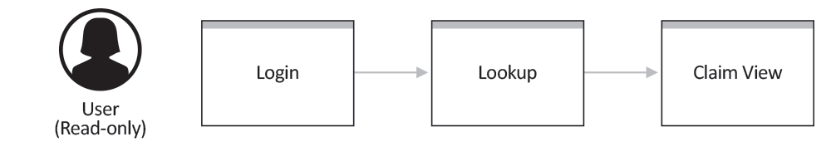

Figure 1 - Data Flow Diagram

## User Access Levels















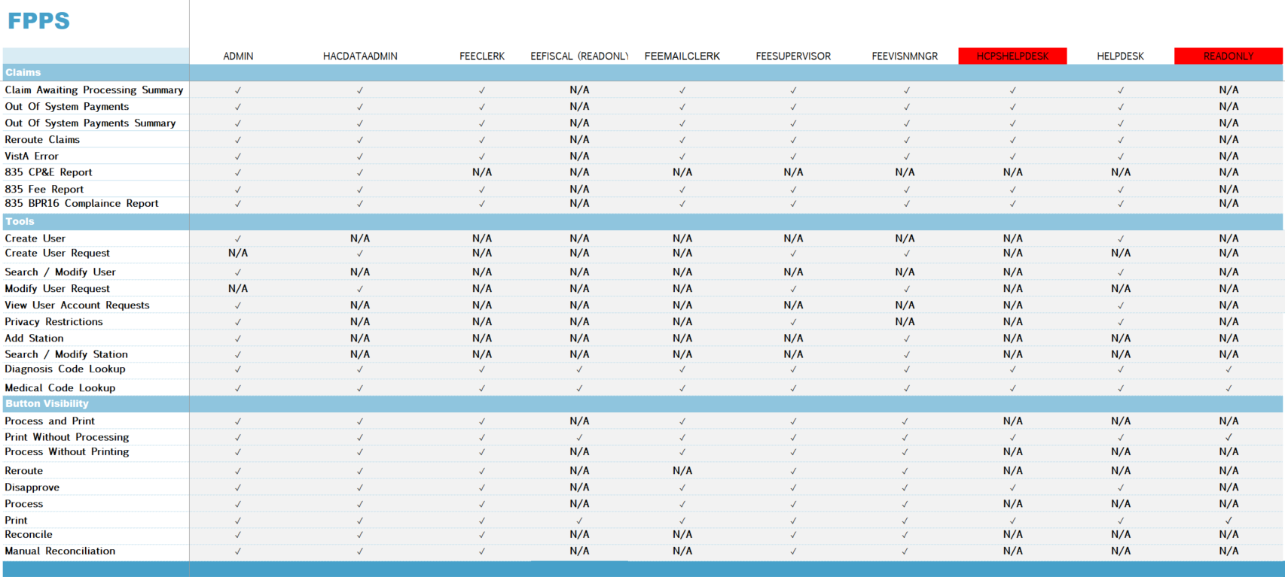

Figure 2 – Reroute Capabilities Matrix

## Continuity of Operation

The existing Disaster Recovery Plan did not change for FPPS systems.

# Getting Started

This section provides a general walkthrough of the system from initiation through exit. Thelogical arrangement of the information shall enable the functional personnel to understand thesequence and flow of the system.

## Logging On

The Login Page does not require the user to enter a username and password to access the FPPS website. The user simply needs to accept the terms of the login page to proceed to use the application. The PIV card at the user’s computer is needed to access the VA network itself, which is where the FPPS website resides. The authentication to access the FPPS website is done not through the PIV card but through the Window GUID (Global Unique Identifier) that is unique to each instance of a Windows Operating System that is running. At the VA’s backend Authentication Service, the GUID sent as part of the authentication is checked to see if it has permission to access the FPPS website and it if does, it also has a set of permissions that decides what that GUID may or may not do when logged into the FPPS website.

Access to FPPS can be obtained through two-factor authentication. With a PIV card inserted into a system accessible card reader, navigate to the FPPS URL. A system access disclaimer will be presented.

Figure 3 - Login Disclaimer

From this page, you can accept the disclaimer.

* Accepting the disclaimer with credentials with access to the FPPS application will progress the user to the Home Page (***see section 4.1***).
* Accepting the disclaimer with credentials lacking access to the FPPS application will display a login error.

## Application Navigation Menu



Figure 5 - Application Navigation Menu

The application navigation menu is shown at the top of all pages after successful initial authorization. The menu includes the Windows NT username of the user currently logged in and the following links and sub-menus:

* Home – Navigates the user to the Home Page (***see section 4.1***)
* Claims – Includes the following sub-menu links:Scrub
  + Search Claims
  + Awaiting Processing
  + In Process
  + Reject Claims
* Tools – Includes the following sub-menu links:
  + Create User
  + Search / Modify User
  + Create User Request
  + Modify User Request
  + Diagnosis Code Lookup
  + Medical Code Lookup
* Logout – Logs the user out of the FPPS application and navigates the user to the Login Disclaimer page

## Exit System

For the user to properly exit the system the user must use the Logout button in the system navigation menu (***see section 3.2***). This button logs the user out of the FPPS application and navigates the user to the Login Disclaimer page.

# Using the Application

## Home Page

Figure 6 - Home Page

The Home Page of the FPPS application allows the user to select a station listing to use as the basis for the claims they will be processing. The user may select none, one, or multiple stations to work with at a time by checking the appropriate checkboxes in a displayed table and clicking the Set Active button. The user may also review their current selections and details about their account through a box at the top of the page.

The Home Page can be navigated to through the click of the Home option in the navigation menu (***see section 3.2***). On the FPPS Home Page, all data points will fill in with data and all stations currently selected by the user will have their associated checkbox selected in the station selection table. All checkboxes are selectable and de-selectable. A selected checkbox is represented by the appearance of a checkmark within the box, while a non-selected checkbox is represented as a black box. The account details box includes the following information:

**User:** The Windows NT user ID of the currently logged in user.

**Active Stations:** An inline list of station identifiers currently selected as active by the user.

**Last Login:** The date and time stamp of the last successful login by the current user.

**Roles:** A list of security roles currently assigned to the current user.

The station selection table includes the following features:

**Header:**

The table header provides a select all stations checkbox and organizational details of the table columns.

* Checkbox – Selects all visible stations in the table
* Station – Column header for the identifier of the station represented by a line in the table
* Claims Awaiting – Column header for the count of claims in the established status and assigned to the station
* Claims In Process – Column header for the count of claims in the in process status and assigned to the station
* Claims Rejected – Column header for the count of claims in the rejected status and assigned to the station

**Table Lines:**

The first line of the table displays information regarding VISN claims. VISN claims are claims that are not assigned to any station.

The remaining lines of the table include the following:

* Checkbox – Selects the specific station represented by the table line on which the checkbox resides
* Data specific to the column header above each data element

**Footer:**

The footer displays the total for each of the columns represented by the table: Claims Awaiting, Claims In Process, and Claims Rejected.

A scroll-bar is available to the right of the table. This scroll-bar allows the user to navigate to additional stations if additional space is necessary to display all station options.

The Set Active button sets all stations currently set as selected active stations for the currently logged in user. When clicked, the account details box will update to show the selected stations and the stations selected in the station selection table will remain selected. This shall not update the totals, as those are aggregate counts of the entire table, not the selected stations.

The Refresh Stats button refreshes the data displayed in the station selection table for all stations displayed.

## Awaiting Processing Page

Figure 7 - Awaiting Processing Page

The Awaiting Processing page provides the user with a list of claims in FPPS that are in the ESTABLISHED status for the selected active stations and VISN claims. This is the default status for a claim. The user may select one or more claims by checking the appropriate checkboxes in claim list. The user may process all selected claims through buttons located at the top and bottom of the screens. The claim operations include Process and Print, Print Without Processing, Process Without Printing, Reroute, and Disapprove. The page also offers navigational functions for the claims list, such as pagination, table sorting, and an Entries Per Page dropdown.

The Awaiting Processing page can be navigated to through the click of the Awaiting Processing option under the Claims header in the navigation menu (***see section 3.2***). On the Awaiting Processing page, all claims considered awaiting processing and associated to the users currently selected stations (***see section 4.1***) will display in the claim list with associated data for each column.

All checkboxes are selectable and de-selectable. A selected checkbox is represented by the appearance of a checkmark within the box, while a non-selected checkbox is represented as a black box.

The Awaiting Processing claim list table includes the following information:

**Header:**

The table header provides a select all claims checkbox and organizational details of the table columns. The user may click on any header to alternate between sorting ascending and descending based on the data included in the column for all claims returned.

* Checkbox – Selects all visible claims in the table
* Claim ID – Column header for the numerical identifier of the claim
* Claim Type – Column header for the type of claim – Institutional, Professional, or Dental
* Program Indicator – Column header for the program indicator, which indicates which program the claim is associated with, defaulting to VA FEE if there is no program associated with the claim.
* Name – Column header for the first and last name of the veteran associated with the claim.
* SSN – Column header for the SSN of the veteran associated with the claim.
* Claim Date – Column header for the date of service for the claim.
* Claim Amount – Column header for the billed amount for the claim.
* Provider– Column header for name of the service provider for the claim.
* Total Lines – Column header for the count of line items on the claim.
* Facility – Column header for the station number the claim is assigned to.

**Table Lines:**

Each line of the claim list table includes the functionality to select each claim via a checkbox on the left. The remaining data corresponds with the table header as stated above.

**Table Navigation Features:**

The following features are included above and below the table:

* Number of results – A count of claims in the system with the status associated with Awaiting Process and assigned to the users currently selected stations (***see section 4.1***).
* Arrow – Navigates the user forward or backward a page of claims.
* Entries/Page – A dropdown used to set how many claims should display per page of the table.

**Buttons:**

The Awaiting Processing page offers the following buttons at the bottom of the page:

* Process and Print – Sets all selected claims to the status of INPROCESS and produces a PDF version of the selected claim(s) for printing. Please see Section 4.49 - Sample Print PDF File of Claims to view a sample claim .pdf file.
* Print Without Processing – Produces a PDF version of all selected claims for printing. Please see Section 4.49 - Sample Print PDF File of Claims to view a sample claim .pdf file.
* Process Without Printing – Sets all selected claims to the status of INPROCESS
* Reroute – Reroutes claims to another VISN or station using the Reroute page (***see section 4.16***)
* Disapprove – Disapproves selected claims by setting its status to REJECTED. User will be forwarded to the Reject Claims page whereby the user will be given the opportunity to select which Claims selected previously will be placed into the REJECTED state. (***see section 4.12***).

## In Process Page

Figure 8 - In Process Page

The In Process page provides the user with a list of claims in FPPS that are in the INPROCESS status for the selected active stations and VISN claims. The user may select one or more claims by checking the appropriate checkboxes in claim list. The user may process all selected claims through buttons located at the top and bottom of the screens. The claim operations include Print, Reroute, and Disapprove. The page also offers navigational functions for the claims list, such as pagination, table sorting, and an Entries Per Page dropdown.

The In Process page can be navigated to through the click of the In Process option under the Claims header in the navigation menu (***see section 3.2***). On the In Process page, all claims considered in process and associated to the users currently selected stations (***see section 4.1***) will display in the claim list with associated data for each column.

All checkboxes are selectable and de-selectable. A selected checkbox is represented by the appearance of a checkmark within the box, while a non-selected checkbox is represented as a black box.

The In Process claim list table includes the following information:

**Header:**

The table header provides a select all claims checkbox and organizational details of the table columns. The user may click on any header to alternate between sorting ascending and descending based on the data included in the column for all claims returned.

* Checkbox – Selects all visible claims in the table
* Claim ID – Column header for the numerical identifier of the claim
* Claim Type – Column header for the type of claim – Institutional, Professional, or Dental
* Program Indicator – Column header for the program indicator, which indicates which program the claim is associated with, defaulting to VA FEE if there is no program associated with the claim.
* Name – Column header for the first and last name of the veteran associated with the claim.
* Claim Date – Column header for the date of service for the claim.
* Provider– Column header for name of the service provider for the claim.
* Total Lines – Column header for the count of line items on the claim.
* Lines Closed – Column header for the count of the claims line items that are in a closed status.
* Facility – Column header for the station number the claim is assigned to.

**Table Lines:**

Each line of the claim list table includes the functionality to select each claim via a checkbox on the left. The remaining data corresponds with the table header as stated above.

**Table Navigation Features:**

The following features are included above and below the table:

* Number of results – A count of claims in the system with the status associated with Awaiting Process and assigned to the users currently selected stations (***see section 4.1***).
* Arrow – Navigates the user forward or backward 10 pages of claims.
* Entries/Page – A dropdown used to set how many claims should display per page of the table.

**Buttons:**

The In Process page offers the following buttons at the bottom of the page:

* Print – Produces a PDF version of all selected claims for printing. Please see Section 4.49 - Sample Print PDF File of Claims to view a sample claim .pdf file.
* Reroute – Reroutes claims to another VISN or station using the Reroute page (***see section 4.16***)
* Disapprove – Disapproves selected claims by setting its status to REJECTED. User will be forwarded to the Reject Claims page whereby the user will be given the opportunity to select which Claims selected previously will be placed into the REJECTED state. (***see section 4.12***).

## Search Claim Page

Figure 10 - Search Claim Page

The Search Claim page allows a FPPS user to find claims stored in the system using search criteria. Using a search parameter form, the user can produce a list of claims from which one or more can be selected to be printed, rerouted, or disapproved. The user can also access the Claim Details page (***see section 4.6***) by clicking the claim ID listed in the claim list table. The Search Claim page can be navigated through by clicking on the Search Claim option under the Claims header in the navigation menu (***see section 3.2***). All claim search criteria and the claims list will be blank on the Search Claim page.

All checkboxes are selectable and de-selectable. A selected checkbox is represented by the appearance of a checkmark within the box, while a non-selected checkbox is represented as a black box.

The Search Claim search parameters form will return claims based on the following criteria:

* Claim Type – Claims which are considered Institutional, Professional, Dental, or any type (All).
* Last Name – Claims with veterans with last names matching this criterion.
* Check / EFT / TRN – Claims which have been paid and have a check, EFT, or TRN identifier matching this criterion.
* Claim Status – Claims which have a status of ESTABLISHED, INPROCESS, REJECTED, COMPLETE, or any status (All).
* SSN – Claims with veterans have social security numbers matching this criterion.
* Provider TIN – Claims that have been submitted by providers with tax identification numbers matching this criterion.
* Begin Service Date – Claims with a date of service after the date entered for this criterion.
* Claim ID – Claims with identifiers matching this criterion.
* Patient Control Number – Claims with veterans whose patient control number (PCN) match this criterion.
* Provider NPI – Claims that have been submitted by provider with a national provider index matching this criterion.
* End Service Date – Claims with a date of service before the date entered for this criterion.
* Program Indicator – Dropdown parameter for the program indicator, which indicates which program the claim is associated with, defaulting to All, VA Fee denotes no specific Program Indicator
* Include VISN-only Claims – When user has permission: When checked, returns claims that belong to a VISN but not to any specific station.

Both date search criteria fields (Begin Service Date and End Service Date) include a calendar date selection option. When the user clicks the form field, a calendar dialog appears and allows for navigation and selection of a specific date. This calendar also allows for the 508 Compliant shortcuts outlined below:

**Escape –** Closes the calendar dialog

**Shift + Up/Down/Left/Right –** Increase/decrease the year by 1

**Alt + Up/Down/Left/Right –** Increase/decrease the years by 10

**Arrow Keys –** Navigate through the date selection

**Enter –** Select a highlighted date

**Ctrl+Shift+Up –** Opens a month list view on first entry and a year list view on second entry

**Ctrl+Shift+Space –** Select a highlighted year in the year list view or highlighted month in the month list view

**Ctrl+Shift+T –** Return to today’s week

**Ctrl+Shift+C –** Clear the date selection

The Search Claim search parameters also accept wildcard values. The Explain Wildcards link underneath the form explains the accepted uses of underscore (_) as a single character replacement and percent sign (%) as a string replacement.

Once the appropriate search criteria have been entered into the search parameters form, the user may click the Search button to bring up a list of matching claims. The Clear Form button will reset all criteria to the default values present when the Search Claims page is first rendered.

Within the results section of the page is a data element that is displayed when a search is run:

* Number of results – A count of claims in the system matching the criteria entered into the search parameters and assigned to the users currently selected stations (***see section 4.1***).

Figure 11 - Claim Search Page Wildcards Explination

The Search Claims results table includes the following information:

**Header:**

The table header provides a select all claims checkbox and organizational details of the table columns. The user may click on any header to alternate between sorting ascending and descending based on the data included in the column for all claims returned.

* Checkbox – Selects all visible claims in the table
* Claim ID – Column header for the numerical identifier of the claim
* Type – Column header for the type of claim – Institutional, Professional, or Dental
* Status – Column header for the status of the claim – ESTABLISHED, INPROCESS, REJECTED, COMPLETE.
* Program – Column header for the program indicator, which indicates which program the claim is associated with, defaulting to VA FEE if there is no program associated with the claim.
* Attach. – Column header for indication of a claim attachment associated with the claim (Yes/No).
* Name – Column header for the first and last name of the veteran associated with the claim.
* SSN – Column header for the SSN of the veteran associated with the claim.
* Patient Ctl# – Column header for the Patient Control Number (PCN) for the veteran associated with the claim.
* Service Date – Column header for the date of service for the claim.
* Provider – Column header for name of the service provider for the claim.
* Pr TIN – Column header for the tax identification number for the service provider associated with the claim.
* Pr NPI – Column header for the national provider index
* Facility – Column header for the station number the claim is assigned to.

**Table Lines:**

Each line of the claim list table includes the functionality to select each claim via a checkbox on the left. The remaining data corresponds with the table header as stated above.

**Buttons:**

The Search Claims page offers the following buttons at the top and bottom of the search results list:

* Print – Produces a PDF version of all selected claims for printing ***(see Section 4.49)*** - Sample Print PDF File of Claims to view a sample claim .pdf file.
* Reroute – Reroutes claims to another VISN or station using the Reroute page (***see section 4.15***)
* Disapprove – Disapproves selected claims by setting its status to REJECTED. User will be forwarded to the Disapprove Claims page whereby the user will be given the opportunity to select which Claims selected previously will be placed into the REJECTED state (***see section 4.12***).

## Claim Detail Page

Figure 12 - Claim Detail Page

The Claim Detail page provides FPPS users with details about a claim. The page displays a different dataset based on the type of the selected claim. The user has a choice to review subsets of claim data via the tabbed table under the Veteran Information, Service Provider Information, Billing Provider Information, or Pay-to Provider Information boxes. The user can also Print, Reroute, or Disapprove on the currently displayed claim by clicking the buttons at the bottom of the page.

The Claim Detail page can be navigated through clicking on a claim ID on any claim list in the system. All claim details that exist in the database for the selected claim will be displayed in the fields provided on the Claim Detail page.

For all claim types, the following details are shown at the top of the page:

* Claim ID – The numerical identifier of the claim.
* Patient Control # - The identifier for the veteran.
* Pre-authorization # - The pre-authorization number for the claim payment.

All claim types display the following data in the data cards under the claim identification header:

**Veteran Information:**

ID – The numerical identifier of the veteran served on the claim.

First Name – First name of the contact veteran

Last Name – Last name of the contact veteran

Middle Name – Middle name of the contact veteran

Address 1 – First line of the veteran’s contact address

Address 2 – Second line of the veteran’s contact address

City – City of the veteran’s contact address

State – State of the veteran’s contact address

Zip – Zip of the veteran’s contact address

Phone – Phone number of the veteran’s contact address

DOB – The veteran’s data of birth

Gender – The veteran’s gender

**Service Provider Information:**

Name – Name of the provider performing the service listed the claim

Address 1 – First line of the service provider contact address

Address 2 – Second line of the service provider contact address

City – City of the service provider contact address

State – State of the service provider contact address

Zip – Zip of the service provider contact address

Phone – Contact phone number for the service provider

Tax ID – Tax identification number of the service provider

NPI – National Provider Identifier number of the service provider

Contact Name – Name of the primary contact of the service provider

Fax – Fax number for the primary contact of the service provider

Email – Email address for the primary contact of the service provider

**Billing Provider Information:**

Name – Name of the provider who has submitted the claim bill for payment

Address 1 – First line of the billing provider contact address

Address 2 – Second line of the billing provider contact address

City – City of the billing provider contact address

State – State of the billing provider contact address

Zip – Zip of the billing provider contact address

Phone – Contact phone number of the billing provider

Tax ID – Tax identification number of the billing provider

NPI – National Provider Identifier number of the billing provider

Contact Name – Name of the primary contact of the service provider

Fax – Fax number for the primary contact of the service provider

Email – Email address for the primary contact of the service provider

**Pay-to Provider Information:**

Name – Name of the provider who is to be paid for the services on the claim

Address 1 – First line of the pay-to provider contact address

Address 2 – Second line of the pay-to provider contact address

City – City of the pay-to provider contact address

State – State of the billing provider contact address

Zip – Zip of the pay-to provider contact address

Phone – Contact phone number of the billing provider

Tax ID – Tax identification number of the billing provider

NPI – National Provider Identifier number of the billing provider

All claim types display the following data in the tabs underneath the data cards:

**Additional Info:**

Other Insurance # (Secondary Payer) – The insurance identifier of the insurance group who was the second payer on the claim

Other Insurance Plan (Secondary Payer) – The insurance plan of the insurance group who was the second payer on the claim

Other Insurance # (Tertiary Payer) – The insurance identifier of the insurance group who was the third payer on the claim

Other Insurance Plan (Tertiary Payer) – The insurance plan of the insurance group who was the third payer on the claim

Ambulance Transport Reason (Professional Claim Only) – Reason given by provider for the transport of the patient by an ambulance

Admission Date – The date the veteran was admitted into the service provider

Discharge Date – The date the veteran was discharged from the service provider

Covered Days – The count of days the veteran was covered by insurance during the stay with the service provider

Provider DRG (Institutional Claim Only) – The Diagnosis Related Group of the Provider which has requested payment for this claim.

Attending Physician (Institutional Claim Only) – The name of the primary care physician who attended to the veteran

Treasury Payment Date (PD) – The date of the rendering of payment by treasury for this claim.

Total Paid Amt per PD (Institutional and Dental Claim Only) – Total amount of payment rendered by Treasury for this claim and its line items.

Total Claim Amount Paid (Professional Claim Only) ­– Total amount paid by the Treasury for this claim.

Check/EFT/TRN – The reference number for the Check, Electronic Funds Transfer, or Transaction Reference Number for the payment rendered by Treasury for this claim.

**Diagnosis Codes:** (Institutional and Professional Claim Only)

For each diagnosis code included on the claim, the following data is displayed:

Sequence Number – Sequence Number of Diagnosis Code

Diagnosis Code – Numerical ICD10 code of the claim diagnosis

POA Indicator – The Present on Arrival indicator for the diagnosis

Description – A brief text description of the diagnosis

DX Type – Indicates ty[e of the diagnosis

**Line Items:**

Line ID – Line ID for the line item procedure

Medical Code (Institutional and Professional Claim Only) – ICD10 code for the line item procedure

Tooth # (Dental Claim Only) – Tooth affected for the line item procedure

Surface Code (Dental Claim Only) – Surface Dental code for the line item procedure

Service (Dental Claim Only) – Service of line item procedure

Description (Professional Claim Only) – A brief text description of the diagnosis

Diagnosis Pointers (Professional Claim Only) – Diagnosis Pointers for this procedure line item

Revenue Code (Institutional Claim Only) – Associated revenue code for the line item procedure

Service From Date – The date the procedure began

Service To Date – The date the procedure ended

Billed Amount – The amount billed by the billing provider

Billed Units (Professional Only) – The count of units that were billed for this procedure

Modifiers – Modifier applied to the payment for this procedure

Line Status – The status of the claim line item

Treasury Payment Date – The date of payment by the treasury covering this procedure

Paid Amount – The amount paid by treasury for this procedure

Check/EFT/TRN – The identifier of the check or payment made on the procedure

Adjustment Amount – Any adjustment of the payment made

Group Code – The adjustment code applied to the payment on this line item

Reason Code – The Reason code applied to the payment on this line item

RARC – The Remittance Advice code applied to the payment on this line item

**Rerouting History:**

This section displays an item for each time the claim has been rerouted. The following data will repeat for each entry:

Date – The date the reroute was initiated

Reason – Reason selected for the reroute

Explanation – Description of why the reroute was performed

Transfer To– The VISN/Facility/User the claim has been assigned to as a result of the reroute

Transfer From – The assigned VISN/Facility/User prior to the reroute

Transferred By – The FPPS user initiating the reroute request

**Rejection History:**

Date – Date rejection was requested

Rejected By – The FPPS user initiating the rejection request

Reason – The reason for the claim rejection

Explanation – The explanation of the claim rejection

Reviewed By – The FPPS user who has reviewed the claim rejection

Outcome – The outcome of the claim rejection review

Reviewer Comments – Any comments left by the rejection reviewer

**Buttons:**

All claim types allow the user to perform the following tasks via buttons at the bottom of the screen:

* Process – Sets selected claim to the status of INPROCESS
* Print – Produces a PDF version of all selected claims for printing ***(see Section 4.49)*** - Sample Print PDF File of Claims to view a sample claim .pdf file.
* Reroute – Reroutes claims to another VISN or station using the Reroute page (***see section 4.15***)
* Disapprove – Disapproves selected claims by setting its status to REJECTED. User will be forwarded to the Disapprove Claims page whereby the user will be given the opportunity to select which Claims selected previously will be placed into the REJECTED state (***see section 4.12***).

Figure 13 - Claim Detail Page - Institutional Claim

The institutional claim includes the following data under the Additional Info tab:

* Secondary Payer Other Insurance Number
* Secondary Payer Other Insurance Number
* Tertiary Payer Other Insurance Number
* Tertiary Payer Other Insurance Plan
* Admission Date
* Discharge Date
* Covered Days
* Provider DRG
* Attending Physician
* Treasury Payment Date (PD)
* Total Paid Amt per PD
* Check/EFT/TRN

Figure 14 - Claim Detail Page - Professional Claim

The professional claim includes the following data under the Additional Info tab:

* Secondary Payer Other Insurance Number
* Secondary Payer Other Insurance Number
* Tertiary Payer Other Insurance Number
* Tertiary Payer Other Insurance Plan
* Ambulance Transport Reason
* Total Claim Amount Paid
* Treasury Payment Date (PD)
* Total Claim Amount per PD
* Check/EFT/TRN

Figure 15 - Claim Detail Page - Dental Claim

The professional claim includes the following data under the Additional Info tab:

* Treasury Payment Date (PD)
* Total Paid Amount per PD
* Check / EFT / TRN
* Total Amount per CARC

## Reject Claims Page

Figure 19 - Reject Claims Page

The Reject Claims page allows a FPPS user to select one or many claims and accept or reverse a disapproval. Additionally, a comment can be applied to a claim prior to accepting or rejecting its disapproval and the history of a claim’s disapproval can be displayed.

The user may select claims in the disapproved claims table and click either the “OK Disapproval” or “Reverse Disapproval” button at the bottom of the page. “OK Disapproval” will apply any comment added, set the claims to Complete, and reject any line items included in the claim. “Reverse Disapproval” will return the claim to an “Established” status. Both of these functions remove the claim from the table listing on this page.

The Disapproved Claims table provides a summary of claims in Disapproved status. The Disapproved Claims table includes the following information:

**Header:**

The table header provides a select all claims checkbox and organizational details of the table columns. The user may click on any header to alternate between sorting ascending and descending based on the data included in the column for all claims returned.

* Checkbox – Selects all visible claims in the table
* Claim ID – Column header for the numerical identifier of the claim
* Claim Type – Column header for the type of claim – Institutional, Professional, or Dental
* Program Indicator – Column header for the program indicator, which indicates which program the claim is associated with, defaulting to VA FEE if there is no program associated with the claim.
* Patient ID – The numerical identifier of the patient tied to the claim.
* Claim Date – Column header for the date of service for the claim.
* Claim Amount – Column header for the amount billed by the provider for the claim.
* Provider – Column header for name of the service provider for the claim.
* Disapproved By – The Windows NT name of the user who set the claim to the disapproved status.
* Disapproved Date – The date the claim was set to the disapproved status.
* Reason – The numerical identifier of the reason code set when the claim was disapproved.
* Explanation – The comment applied to the claim when the claim was disapproved.
* Comments – Column containing a button for applying a comment on the acceptance or reversal of a disapproval.
* History – Column containing a button for displaying the Rejection History of a claim.

**Table Lines:**

Each line of the disapproved claim list table includes the functionality to select each claim via a checkbox on the left. The remaining data corresponds with the table header as stated above. Each line includes a Comment button, which will display a pop-up window allowing the entry of a comment for a claim prior to accepting or reversing its disapproval, and a History button, which will display a Claim Rejection history for the claim on that line.

**Table Navigation Features:**

The following features are included above and below the table:

* Number of results – A count of claims in the system with the status Disapproved and assigned to the users currently selected stations (***see section 4.1***).
* Double Arrow – Navigates the user forward or backward 10 pages of claims.
* Entries/Page – A dropdown used to set how many claims should display per page of the table.

**Buttons:**

The Rejected Claim page offers the following buttons at the bottom of the page:

* OK Disapproval – Sets any selected claim in the Disapproved Claims table above to the Completed status and any line items to the Rejected status. This will remove the claim from the table, apply any comment added via the Comment button, and show an OK in the rejection history of the claim.
* Reverse Disapproval – Sets any selected claim in the Disapproved Claims table above to the Established status. This will remove the claim from the table, apply any comment added via the Comment button, and show a REVERSED in the rejection history of the claim.

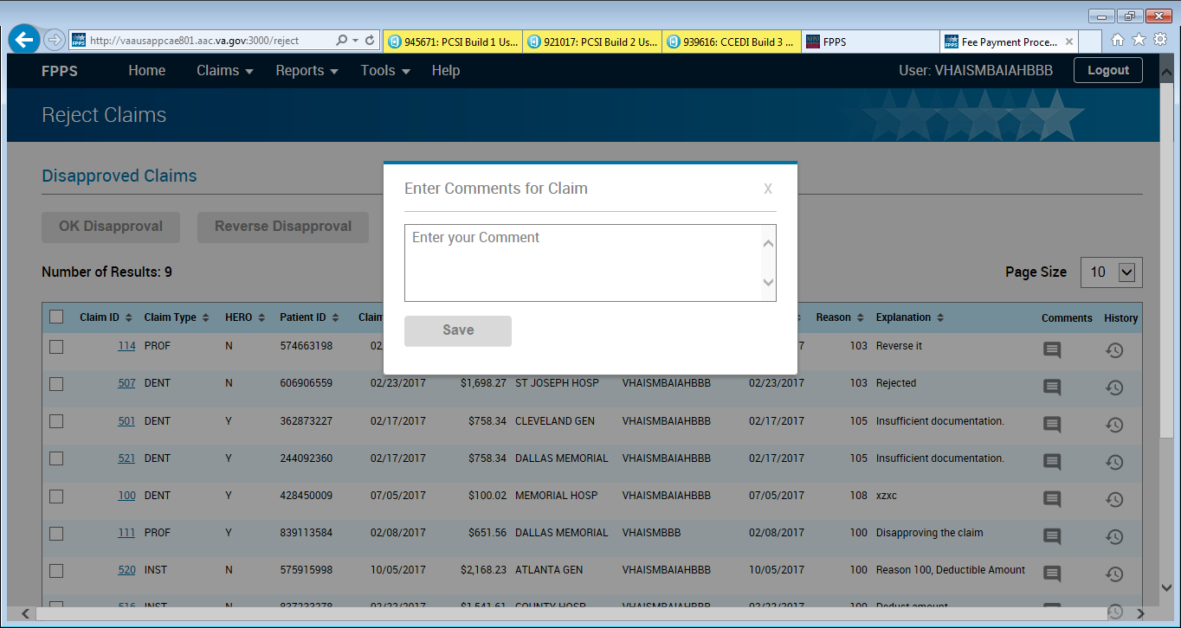

Figure 20 – Reject Claims Page - Comment Modal

When applying a comment to a claim, a window appears, providing a text box to enter a text comment into. This window includes the claim id of the claim the comment will apply to in the header. Once a comment has been entered, a save button is provided which will keep the comment attached to that record.

**NOTE:** To complete the step of applying a comment to a claim disapproval, the disapproval must be accepted or reversed after entering the comment into the comment window.



Figure 21 – Reject Claims Page - Rejection History Table

The Disapproved Claims History table provides historical summary of a claims disapproval history. The Disapproved Claims History table includes the following information for each previous disapproval executed for the selected claim:

**Header:**

* Date – The date of the disapproval of the claim
* Rejected By – The Windows NT name of the user who initiated the disapproval
* Reason – The numerical reason code for the disapproval
* Explanation – Any comment left on the disapproval
* Reviewed By – If the claim disapproval was reversed or accepted, this is the Windows NT name of the user who reversed or accepted the disapproval
* Outcome – Either OK or REVERSED if the claim disapproval was accepted or reversed
* Reviewer Comments – Any comment left on the claim if the claim disapproval was accepted or reversed

**Table Lines:**

The data in the table lines corresponds with the table header as stated above. Reviewer, Outcome, and Reviewer’s Comments will only appear for a claim disapproval record if the disapproval was accepted or rejected.

## Disapprove Claims Page

Figure 22 – Disapprove Claims Page

The Disapprove Claim page allows a FPPS user to select a reason code and add comments to a disapproved claim through a queue page or the claim detail page. The reason code is required and is selectable from the Reason drop down box at the top of the page. The user may choose to provide a detailed disapproval comment in the Comments text box under the Reason box. The maximum character number allowance is 250 within the Comments text box.

Once the user has supplied the disapproval reason code, clicking the Disapprove button will process the claim status and applies the Reason and Comment to be shown on the Disapprove History tab on the claim detail page (***see section 4.6***). Alternatively, clicking the Cancel button will return the user to their previous page and not modify the claim.

A Claims to Disapprove table provides a summary of disapproved claims at the bottom of the page. The Claims to Disapprove table includes the following information:

**Header:**

The table header provides a name for each column of data displayed within the table lines.

* Claim ID – Numerical identifier of the claim.
* Veteran Name – First and last name of the veteran associated with the claim.
* Service Provider – Service provider for the claim.
* Billing Provider – Name of the provider who submitted the claim bill for payment.

**Table Lines:**

Each line of the Claims to Disapprove displays data corresponding with the table header as stated above.

## Reroute Claim Page

Figure 27 – Reroute Claim Page

The Reroute Claim page allows the user to modify the assignment of a claim to a VISN and facility. Once the user selects a new VISN and Facility, and provides a reason, the claim will be assigned to that VISN and Facility and will show up under queues for users with the new station active on their account.

The page includes a claim summary table for the claim selected for rerouting. This table includes the following information:

* Claim ID – Numerical identifier of the claim
* Veteran Name – First and last name of the veteran associated with the claim.
* Provider Name – The service provider associated with the claim.

Below the claim summary table is the destination form. This form allows the user to select the new VISN and station for the selected claim as well as provide a reason and comments for the reroute. The following fields are included on the form:

* VISN – A drop-down with a list of all VA Veteran Integrated Service Network location.
* Facility – A drop-down with a list of every VA facility belonging to the selected VISN.
* Reason – A drop-down with a list of standard reasons for the reroute, including:
  + 1 – Services were authorized by another VA facility
  + 2 – Veterans Fee ID Card from another VA facility
  + 3 – Clinic of Jurisdiction resides elsewhere
  + 4 – Mill-Bill Claims Review
  + 5 – Specific User Assignment
* Comments – A text field allowing the user to enter in any comments supporting the choice to reroute the claim to another VISN and facility

The Reroute Page includes a Reroute button which will commit the claim reroute selections made in the above form. Below the Reroute button is a table showing the history of rerouting the selected claim has experienced. The Reroute History table includes the following information:

* Date – The date of execution of the reroute.
* Reason – The supplied reason for the reroute.
* Explanation – The comment supplied at the time of the reroute.
* Transferred To – The VISN and Facility the claim was rerouted to.
* Transferred From – The VISN and Facility the claim was rerouted from.
* Transferred By – The user who initiated the claim reroute.

## Create User Request Page

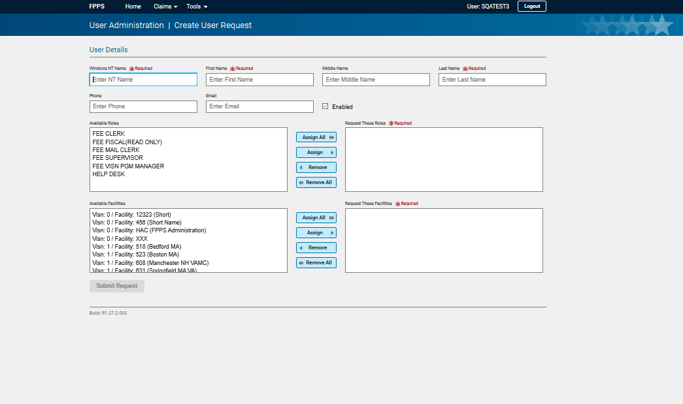

Figure 50 – Create User Request Page

The Create User Request page allows a user to request the creation of a new user account with access to the FPPS application. This request is routed to the FPPS Administration group email address and will appear under the Search User Request page (***see section Search User Request Page).***

This page includes assignment and removal buttons (Assign All, Assign, Remove, and Remove All) for the user to select requested entries from the Available Roles section to the Request These Roles section, and from the Available Facilities section to the Request These Facilities section. At submission of the Create User Request form, selections in the Requested Roles and Facilities sections will indicate to the FPPS Administration group the roles to be assigned to this user at creation.

* Assign All ­– Move all entries from the Available Roles section to the Request These Roles section, and from the Available Facilities section to the Request These Facilities section.
* Assign – Move the selected entry from the Available Roles section to the Request These Roles section, and from the Available Facilities section to the Request These Facilities section.
* Remove – Move the selected entry from the Available Roles section to the Request These Roles section, and from the Available Facilities section to the Request These Facilities section.
* Remove All – Move all entries from the Available Roles section to the Request These Roles section, and from the Available Facilities section to the Request These Facilities section.

Once the user enters all the required field data, clicking the “Submit Request” button creates the Create User Request, communicates the request to FPPS Administration, places the request into the Search User Request queue, and displays a Create User Request success message.

The Create User Request data parameters include the following fields:

* Windows NT Name – Required – The Windows NT account name of the user who will receive the account.
* First Name – Required – First name of the user who will receive the account.
* Middle Name – Middle name of the user who will receive the account.
* Last Name – Required – Last name of the user who will receive the account.
* Phone –Phone number of the user who will receive the account.
* Email – Email address of the user who will receive the account.
* Available Roles – A list of all possible FPPS application security roles which are available to select for the user who will receive the account.
* Request These Roles – A list of FPPS application security roles which have been added for the user who will receive the account.
* Availability Facilities – A list of all possible VISN/station facilities which are available to select for the user who will receive the account.
* Request These Facilities – A list of VISN/station facilities which have been added for the user who will receive the account.

## Diagnosis Code Lookup Page

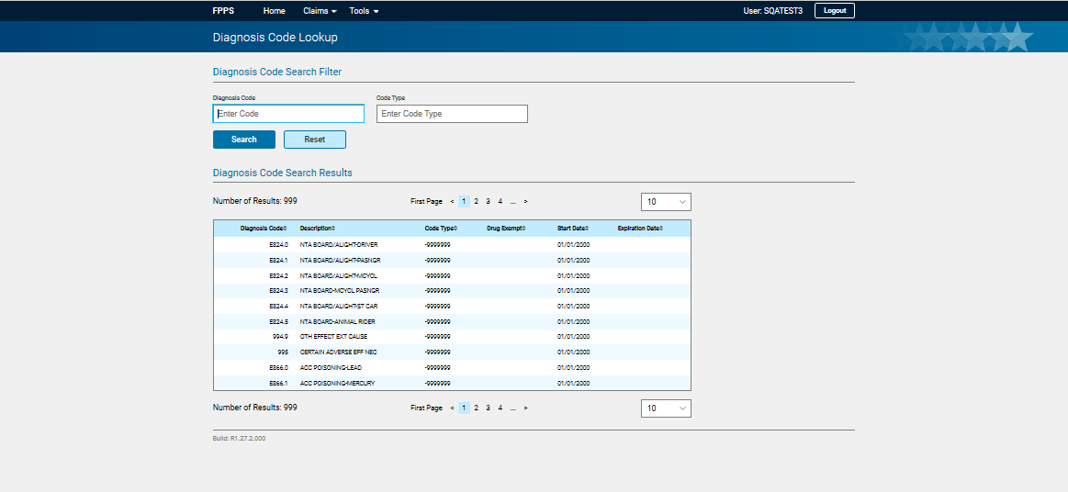

Figure 605961 57 – Diagnosis Code Lookup Page

The Diagnosis Code Lookup page allows a user to research and review diagnosis codes available in the FPPS application. These codes are included on claims to describe a patient diagnosis.

This page includes the following fields to filter the list of Diagnosis Codes:

Diagnosis Code – The standardized alphanumeric code usually found on the claim representing a medical diagnosis requiring the medical procedures performed on the patient.

Code Type – The code standard governing the diagnosis code.

These fields accept wildcards % (representing a string of zero or more characters) or _ (any single character).

On clicking the search button, the system retrieves a list of diagnosis codes and associated data which matches the supplied criteria. On clicking the reset button, any diagnosis code or code type criteria supplied will be cleared.

### Search Diagnosis Code

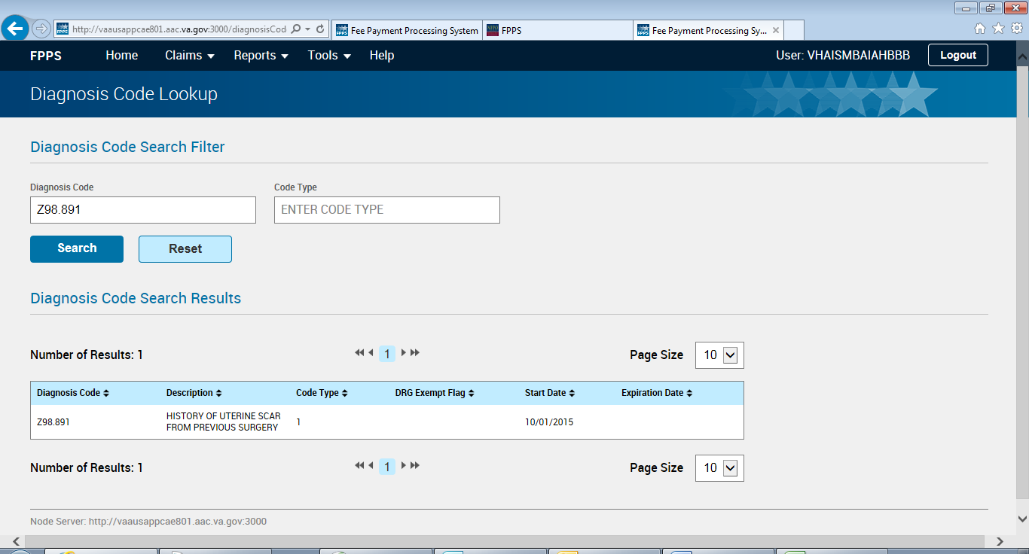

Figure 21 - Search Diagnosis Code Lookup

The diagnosis code search result table contains the following fields:

Diagnosis Code – The standardized alphanumeric code usually found on the claim representing a medical diagnosis requiring the medical procedures performed on the patient.

Description – A text description describing the diagnosis represented by the diagnosis code.

Code Type – The code standard governing the diagnosis code.

DRG Exempt Flag –

Start Date – The beginning date of the validity of the diagnosis code.

Expiration Date – The expiration date of the validity of the diagnosis code.

## Medical Code Lookup Page

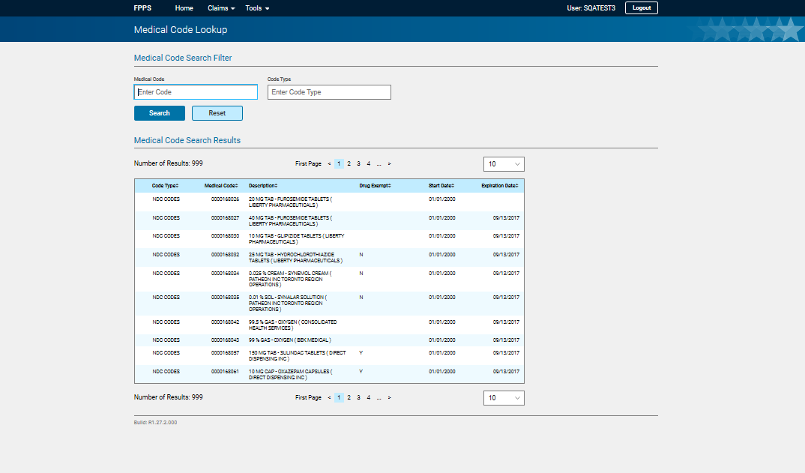

Figure 61 – Medical Code Lookup Page

The Medical Code Lookup page allows a user to research and review medical codes available in the FPPS application. These codes are included on claims to describe a medical procedure performed on a patient.

This page includes the following fields to filter the list of Medical Codes:

Medical Code – The standardized alphanumeric code usually found on the claim representing a medical procedure performed on or service provided to the patient.

Code Type – The code standard governing the medical code.

These fields accept wildcards % (representing a string of zero or more characters) or _ (any single character).

On clicking the search button, the system retrieves a list of medical codes and associated data which matches the supplied criteria. On clicking the reset button, any medical code or code type criteria supplied will be cleared.

The medical code search result table contains the following fields:

* Code Type – The code standard governing the medical code.
* Medical Code – The standardized alphanumeric code representing a medical procedure performed on or service provided to the patient.
* Description – A text description describing the medical procedure or service represented by the medical code.
* Drug Exempt –
* Start Date – The beginning date of the validity of the Medical Code.
* Expiration Date – The expiration date of the validity of the Medical Code.

## Sample Print PDF File of Claims

### Institutional Claim PDF

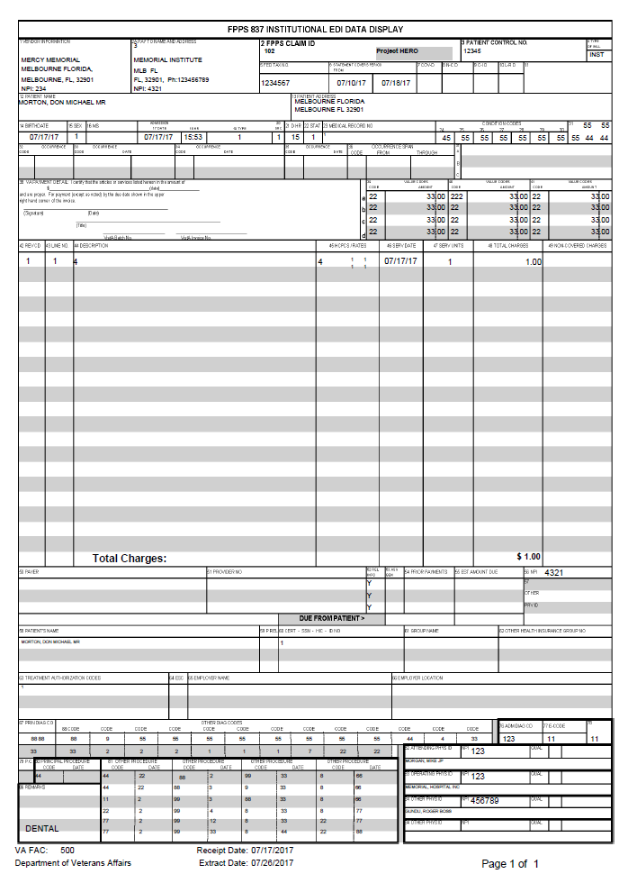

Figure 62 - Institutional Claim .pdf

### Professional Claim PDF

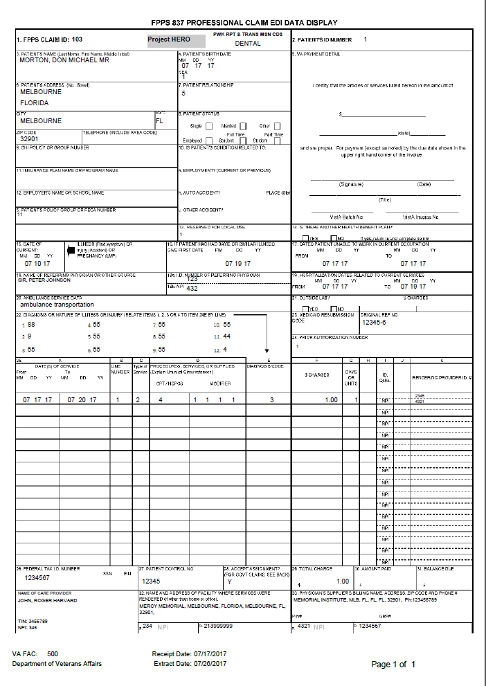

Figure 63 - Professional Claim .pdf

### Dental Claim PDF

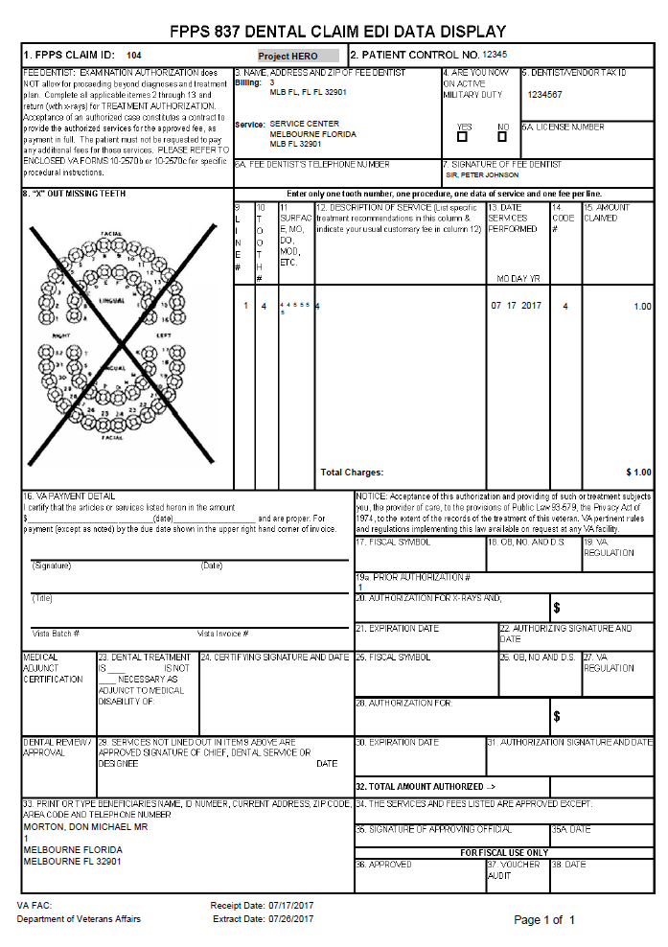

Figure 64 - Dental Claim .pdf

# Troubleshooting

This section is a stub and will be elaborated after development has completed for additional system workflows.

## Special Instructions for Error Correction

This section is a stub and will be elaborated after development has completed for additional system workflows.

.

.

# Acronyms and Abbreviations

|  |  |
| --- | --- |
| **Acronym** | **Definition** |
| CCSE | Community Care System Enhancements – The contract including the PCSI project under which the redesign of the FPPS application was performed |
| CP&E | Claims Processing and Eligibility |
| EDI | Electronic Data Interchange |
| EFT | Electronic Funds Transfer |
| FPPS | Fee Payment Processing System – The veteran healthcare claims review and processing system described by this document |
| ICD | Interface Control Document |
| NPI | National Provider |
| OCC | Office of Community Care – Formerly known as the HAC (Health Administration Center), the Office of Community Care handles VA and non-VA healthcare claims for VHA community care programs |
| PCSI | Purchased Care System Integrity – The project requiring the redesign of FPPS to utilize TRM compliant architecture |
| TAS | Transactions Application Suite |
| TIN | Tax Identification Number |
| TRM | Technical Reference Manual |
| TRN | Transaction Reference Number |
| VA | Department of Veterans Affairs |
| VISN | Veterans Integrated Service Network |
| VistA | Veterans Health Information Systems and Technology Architecture |

# Appendix

This section is a stub and will be elaborated after development has completed for roles and responsibilities.